Formation of Automobile Industrial Cluster in Thailand and the Role of Japanese Firms

Hiroaki Karibe
Yumeko Matsumoto
Rentaro Ohmoto
Kenichi Oshikiri
Naomi Kida
Sho Shinohara
Saiko Wakabayshi

Abstract

Thailand is one of the biggest automobile producing countries in Asia. It is the formation of industrial cluster that supports the automobile industry in Thailand. And the Japanese automobile firms have contributed a lot for the development of the industrial cluster. This paper investigates the role of Japanese automobile firms for the formation of the industrial cluster in Thailand.
This paper is organized as follows. In Chapter 1 we discuss the definitions of the industrial cluster and the present status of automobile cluster in Thailand. In Chapter 2 we discuss the process of entry of Japanese automobile firms into Thailand. In Chapter 3 we discuss the contributions of Japanese firms for the formation of automobile cluster in Thailand.

September 2008

Introduction
Industrial cluster is a new approach to promote industrial development. Especially in developing countries industrial cluster is expected to enhance the international competitiveness of industries. In developed countries too, it is expected to promote community regeneration and innovative activities.
The successful formation of clusters in emerging countries such as automobile cluster in Thailand or IT software cluster in Bangalore, India largely depends on FDI, which is different from the clusters in developed countries such as Silicon Valley that was created naturally.
There are some researches which focus on the link between automobile industry and FDI in Thailand (Ueda(2007)). However, there is no research that clarified how FDI contributed to the formation of automobile cluster in Thailand. This paper focuses on this issue: how Japanese FDI influence on the formation of the automobile cluster in Thailand.
This paper is organized as follows: In Chapter 1 we discuss the definitions of the industrial cluster and the present status of automobile cluster in Thailand. In Chapter 2 we discuss the process of entry of Japanese automobile firms into Thailand. In Chapter 3 we discuss the contributions of Japanese firms for the formation of the automobile cluster in Thailand.

1. Automobile industrial cluster in Thailand
1-1. Definitions of Industrial Cluster
There are numbers of definitions of industrial cluster. Some emphasize special locations, some focuses on special relationships between companies, and some point out the importance of innovative capacity. From many arguments, we picked up two major definitions.
One is the definition by Michael Porter (Porter [1998]). He defines an industrial cluster as “a geographically proximate group of interconnected companies, specialized suppliers, service providers, firms in related industries and associated institutions in particular field that competes but also co-operates”. Porter emphasized the geographical proximity and intimate relationships between various institutions.
Stuart A. Rosenfeld’s (Rosenfeld [1997]) presented another important definition. He describes an industrial cluster as “a geographical concentration of similar, related or complementary business, with active route for business transactions and communications that share specialized infrastructure, labor markets and services, and that are faced with common opportunities and threats”. It is obvious that Rosenfeld’s definition puts weight on the importance of the role of powerful interaction and firm cooperation, contrasted with Porter’s definition that emphasized proximity of geographical location.
Considering these definitions, in this paper, we define a cluster as “geographic concentration of interrelated companies and associated companies in an exceptional proximate location linked by common technologies and skills”.
A cluster generally is characterized as a high level of integration and complementarily. This means that it generates and transfers knowledge and technology among firms and promotes growth and competitiveness of firms.
Such competitive cluster can produce positive externalities such as low distribution costs to its entire regions. The cluster is not simply the agglomeration of related companies but also the center of accumulated competences. This accumulated knowledge of localized and interconnected companies can be very attractive to outside companies and investors confronting decision where to invest.

1-2. Present status of Thailand’s automobile industrial cluster
Thailand is the biggest car manufacturing country in ASEAN. Japanese car makers (assemblers) such as Toyota, Honda, Mitsubishi had urged Japanese auto-parts/components makers to invest in Thailand and to promote technological transfer to Thai automobile companies because car production in Thailand had begun without enough industrial infrastructures. As a result, Thai automobile industrial cluster was formed helped by Japanese auto makers.
In this section, we analyze present situation of automobile industrial cluster in Thailand and relationship between Thai automobile industry and Japanese affiliated automotive firms.
There are many foreign car makers as well as auto-parts makers in Thailand: Toyota, ISUZU, Mitsubishi and Honda as Japanese makers, General Motors and Ford as the U.S. makers, and BMW as European maker. Local contents ratio of automobile produced in Thailand is one of the highest in Asian region. Almost all parts and components can be supplied in Thailand. The main reason for such a high local contents ratio is the formation of automobile industrial cluster in Thailand.
Automobile industrial cluster in Thailand is located in Bangkok Metropolitan Region (BMR), which has been the central industrial area, and Eastern Seaboard Region (ESB), which is the new industrial area. There are 855 automobile companies concentrated in BMR, out of the total 2132 automobile firms in Thailand. Its concentration ratio is 40% (Figure 1.2.1, Table1.2.1).
As a result of the formation of cluster, cost competitiveness of firms is strengthened. Transportation cost and delivery time are saved thanks to the proximity to customers and increased competition among suppliers (Mizuho Research Institute (2003).

Figure1.2.1
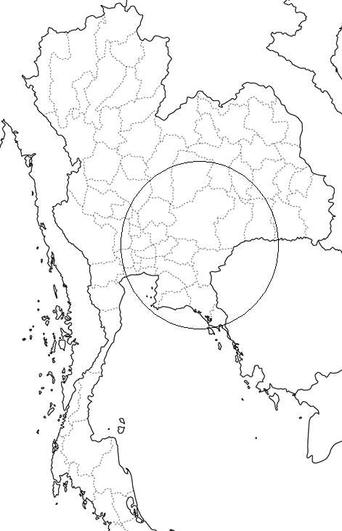
http://www.freemap.jp/about_this_site.html

1…Bangkok 7…Nakhon Pathom
2…Samut Prakarn 8…Ayutthaya
3…Chachoengsao 9…Pathumu Thani
4…Chon Buri 10…Nonthanburi
5…Rayong
6…Samut Sakhon
The number of companies ~40 41~69 70~99 100~399 400~799 800~

Table 1.2.1 Number of Automotive Companies according to Location
 | 企業数
Bangkok | 855
Samut Prakarn | 411
Chon Buri | 223
Ayutthaya | 118
Rayong | 113
Pathumtani | 109
Samutsakorn | 84
Chachoengsao | 61
Nakornprathom | 40
Phranakhonsriayudthaya | 23
Nontaburi | 22
others | 96
Total | 2132
Source：

Next we have a look at the production, the domestic sales and the exports of automobiles. They indicate that both volumes of production and sales have increased since 1990 in spite of the Asian currency crises in 1997. The volume of production reached about to 1.2 million and the volume of sales increased about to 680 thousands in 2006. Besides, the exports since 1997 has been growing steady (Figure 1.2.2) If we look at the volume of production, sales and exports by each maker. In terms of production volume, Toyota occupies the top position, followed by ISUZU, Mitsubishi, Honda, Matsuda, and GM (Figure1.2.3). In terms of sales, again Toyota occupies the top position, followed by ISUZU, Honda, Nissan, Mitsubishi, Chevrolet and Ford (figure1.2.4). Toyota is also the top exporter, followed by ISUZU, Mitsubishi, Honda, Matsuda and GM (Figure1.2.5). In addition, Japanese car makers have 90.6% market share of production, 91.3% of sales and 95.3% of exports. We can safely say that automobile industrial cluster in Thailand has been closely connected with THE activities of the Japanese automobile firms.

Figure 1.2.2
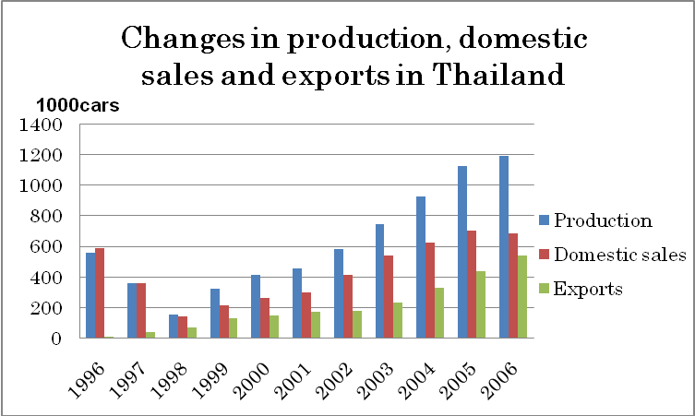
Source: FOURIN, Automobile Annual Statistics 2007.

Figure 1.2.3
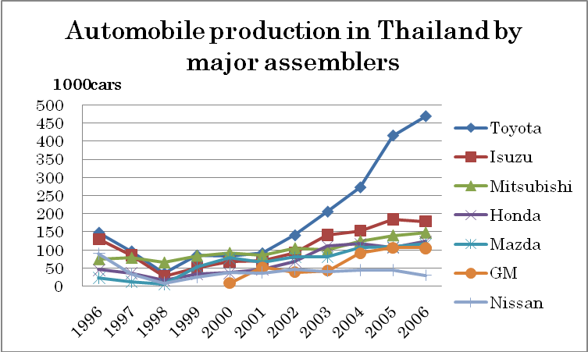
Source: Same as Table 1.2.2.

Figure 1.2.4
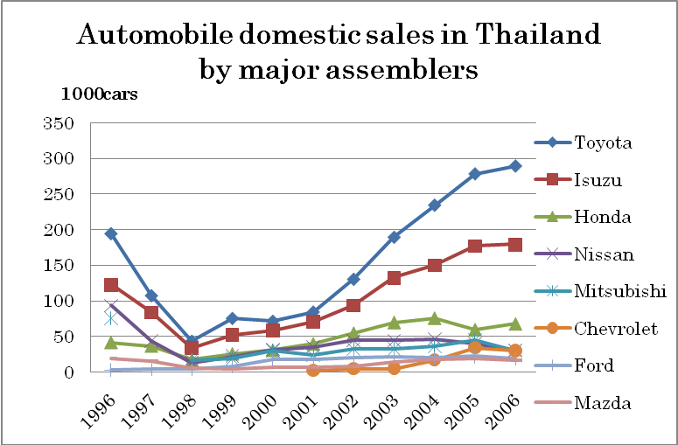
Source: Same as Table 1.2.2.

Figure 1.2.5
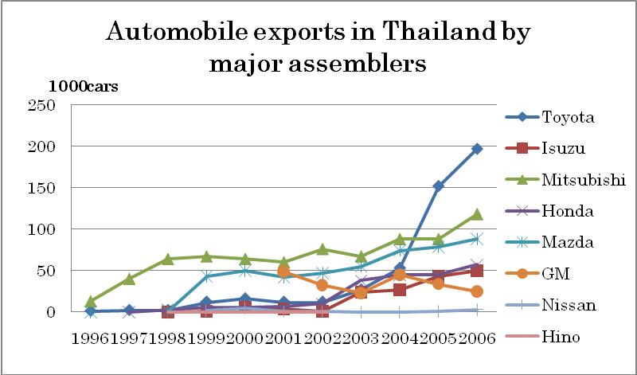
Source: Same as Table 1.2.2.

2. Entry of Japanese firms to Thai automobile industry
2-1. Process of Japanese firms entry into Thai automobile industry
In this section, we analyze the history of Japanese firms’ entry into Thailand automobile sector. We describe the activities of Japanese automobile firms, the automobile policy of the Thai government and those of ASEAN.
The automobile industry in Thailand started in 1960s. Automobile-related firms started their business to produce parts and components such as rubber components, battery and springs. Automobile industry is one of the targeted industries of the Thai government and it has developed significantly due to government industrial policy. In this period, the Thai government adopted the import substitute policy. Because of this policy, the joint venture companies between Japanese makers and local capital were incorporated one after another. Japanese car makers started car production in Thailand by knock down system.
The domestic production of car parts/components was promoted by the Thai government from the 1970s to the first half of 1980s. The Thai government proclaimed a new automotive policy in 1971. This policy introduced local contents regulation. It became obligatory for any foreign company to use domestic products more than 25% in case of cars and 15% to 20% in case of trucks and buses by 1975. In 1978, the Thai government took measure to ban imports of CBU (Under 2,300). As a result, the ratio of automobile made by knock down system occupied about 80% share in the total sales in this year. Since then the ratio of localization went up on and on. In the case of car the localization ratio went up to 30% in 1979. The target of localization by the Thai government was set at 65% that should be attained by 1988. However, finally the ratio was freeze at 54% in 1987. In case of truck and bus the localization ratio went up to 25% in 1980. The target of the Thai government was set at 60% that should be attained by 1988. However, the ratio was reset at 62% for Diesels and 66% for Gasoline from 1989 onwards.

Figure 2.1.1
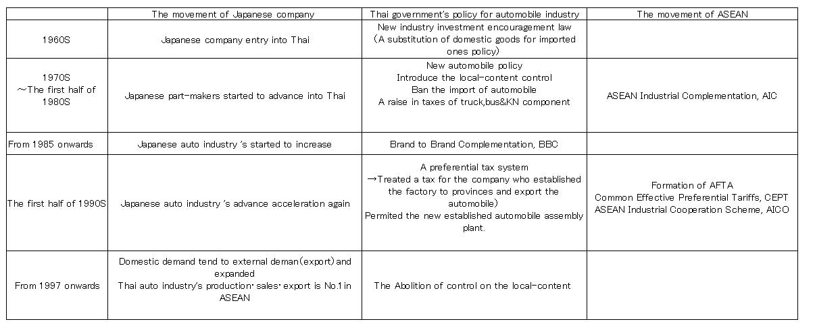
Figure2.1.2
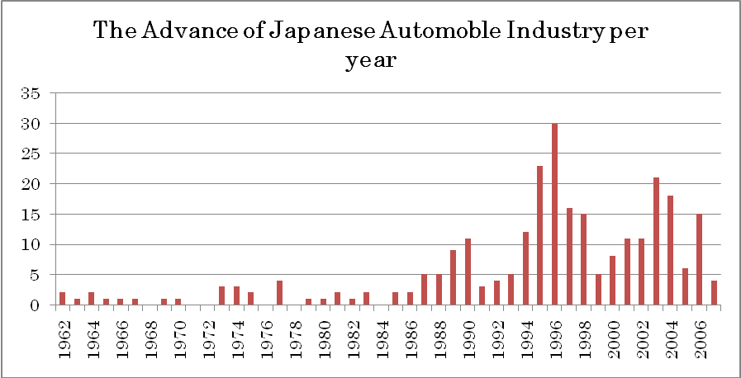
1985 Plaza Accord
1997 The Asian financial crisis
1995 A strong yen rate
Source: Toyo economics [2008] A compendium of the advance of Japanese firm into foreign markets
Note: Except a two-wheeled vehicle components

Although the regulations by the Thai government were so severe, why Japanese firms decided to construct a production base in Thailand? The reason was that both sides had common interests to do so. The Thai government had planned to substitute imported cars by domestic production through Japanese affiliated companies that had technical skills. Then the Industrial Ministry of Thailand prohibited any new established automobile assembly plant to protect Japanese firm’s profits. For Japanese automobile makers there were four reasons to choose Thailand according to Legewie (2000):
- Geographical and cultural proximity between the two countries;
- The market needs of the Southeast Asian countries were mainly for trucks and compact cars that the Japanese makers had comparative advantage;
- Even if Japanese firms were obliged to be turned into the export of components instead of the complete cars, still the ASEAN countries were important customers for Japanese firms;
- Japanese firms had been afraid that entry of European and American car makers to ASEAN countries.

By the Plaza Accord in 1985, yen substantially appreciated. It accelerated FDI from Japan to ASEAN countries. The Thai government launched the ASEAN Industrial Complementation (AIC) scheme. AIC scheme was to aim at being specialized in the production of automobile parts/components in each ASEAN country while harmonizing the local contents and tariffs. However, the AIC scheme was failed. The inter-regional trade under the AIC scheme did not reach even to 1% of the total trade in ASEAN countries. Then Japanese automobile related firms reorganized the automobile industry at the Southeast Asian region. Brand to Brand Complementation (BBC) scheme, which began in 1988, was the first framework which the Japanese firms took lead. BBC was a scheme that only CBU makers led by the Japanese firms could apply to special treatment tariff rate that deduced 50% of imported parts from ASEAN region.
In the first half of 90's, the Thai government began to deregulate imports. Imports of completed car (under 2,300cc) became import duty free in 1990. The import duties for CBU automobile and assembly were drastically reduced in 1991. The enterprise tax was abolished and value added tax was introduced to strengthen the competition of the domestic automobile industry in 1992. The Industrial Ministry of Thailand permitted to establish new automotive assembly plant. BOI revived investment encouragement law for automobile firms and introduced a preference tax for the firms who established the factory in provinces for exports in 1994. Such deregulation measures were taken not only by Thailand but also by other Asian countries. That was a movement which brings AFTA to realize. Asian countries begun to move for the formation of AFTA in 1993. It was agreed to abolish the regional tariff wall by 2015. A first step taken for the realization of AFTA is Common Effective Preferential Tariffs (CEPT). The thing which is ahead of the liberalization in manufacturing industry is ASEAN Industrial Cooperation Scheme (AICO). The list in the below (Table**) compares BBC, CEPT, and AICO. AICO is a framework applied for all types of industries. Actually a lot of automobile firms used this framework. Yen was substantially appreciated again in 1995($1=￥79). Because of Yen appreciation, the outflow of the Japanese automobile industry was accelerated again.

Comparison with BBC, CEPT, AICO
 |  | BBC | CEPT | AICO
Benefit | Import tariffs | Existing import tariffs remit in 50% | 0％－50％ from 2003 onwards | 0％－50％
 | Local production rate | Treat as local item at import country | Every country’s duty system of localization was abolished | Treat as local item at import country
 | Non benefit of import tariffs | Non | Abolish the same system | Exist
 | CBU | Not target | target | Not target
Requirement | The percentage of local content in ASEAN region | 50% | 40% | 40%
 | Participation of local capital | No requirement | No requirement | The firm invest more than 30% of local capital
 | Target | Automotive makers (Reciprocal supply of component by brand owner) | All industries | All types of industry
 | A firm apply for | More than two firms(Reciprocal trade) | One firm（One way is OK） | More than two firms(Reciprocal trade)
 | Starting year | １９８８ | 1993 | 1996
Source： 機械振興協会経済研究所(2001) p. 87

Thailand economy was attacked by the Asian financial crisis in 1997. The domestic sales of automobiles were decreased sharply. So, each maker reinforced export. After 1999, the production of cars increased again with the recovery of the domestic markets. The Thai government abolished the local contents regulation of cars in 2000. The Thai government changed her stance to strengthen the international competitiveness of automobile industry.

2-2. Competitive advantage of Thailand as a destination of Japanese firms
The total number of the entry of Japanese automotive-related companies to Thailand is the biggest among ASEAN4 (see Table2.2.1). In addition, we can find other three features from Table **. First, before 1965 the Japanese automotive-related companies entered only to Thailand among ASEAN countries. Second, the number of the entry to Thailand had been the biggest from 1985 (the Plaza Accord) to 1997 among ASEAN countries. Third, again it has been bigger than those of the others after the Asian Financial Crisis (except 2002). From these features, we can consider that Thailand has had some kind of advantages.

Table2.2.1 The number of the entry of Japanese automotive-related companies¹⁾ to ASEAN4
Year | Thailand | Malaysia | Indonesia | Philippines
Before1965 | 6 | 0 | 0 | 0
1966-70 | 4 | 3 | 2 | 0
1971-75 | 8 | 1 | 5 | 2
1976-80 | 6 | 2 | 12 | 2
1981-85 | 7 | 6 | 1 | 1
1986-90 | 32 | 14 | 7 | 4
1991-95 | 47 | 8 | 15 | 14
1996 | 30 | 5 | 8 | 7
1997 | 16 | 1 | 10 | 2
1998 | 15 | 1 | 2 | 1
1999 | 5 | 1 | 4 | 1
2000 | 8 | 2 | 1 | 1
2001 | 11 | 0 | 10 | 2
2002 | 11 | 0 | 12 | 5
2003 | 21 | 1 | 7 | 1
2004 | 18 | 1 | 4 | 1
2005 | 6 | 1 | 1 | 0
2006 | 15 | 1 | 4 | 0
2007 | 4 | 0 | 1 | 0
Total | 270 | 48 | 106 | 44
Source: Toyo-keizai-shinposha（2008）Kaigai-shinshutsu-kigyo-soran Kaisyabetsuhen
- Except motor bicycle-related parts

Dunning advocated the OLI paradigm (the eclectic paradigm)⁾ for understanding behaviors of multinational enterprises (MNEs) and he tried to clarify the deciding factor that MNEs engaging in manufacturing transfers production activities abroad (Dunning[1977,1979]). We analyze the advantages of Thailand referring to hypothesis of Dunning and compare its advantages with those of Malaysia, Indonesia and Philippines.

Why did Japanese automobile-related companies enter only Thailand before 1965?
To begin with, we investigate main reasons that Japanese automobile-related
companies started to entry into Thailand. The automobile industry of Thailand had been protected by the government under the import substituting industrialization (ISI) strategy, which started in 1962. The ISI is a policy to protect domestic industry, but the government of Thailand permitted the inflow of foreign capital because Thailand didn’t have an automobile manufacturing technology. Then, Toyota, Nissan, Mitsubishi, and so on entered Thailand (Ueda [2007]). In sum, the ISI permitted foreign capitals to play a pivotal role for making automobile industry in Thailand.
On the other hand, other ASEAN countries didn’t choose such a kind of policy before 1965. Malaysia started the ISI just in 1966. Before 1965 Malaysia permitted to import complete cars. Therefore Japanese automobile-related companies didn’t enter Malaysia before 1965. Indonesia banned the imports of the complete cars in 1969 and the Philippines announced the localization of passenger car plan in 1971, so the entry of Japanese automotive-related companies to these two countries too became active only after those policies were adopted.

Why did Japanese automobile-related companies choose Thailand after the Plaza Accord?
Japanese automobile-related companies had entered not only to Bangkok and Samut Prakan, but also to the Eastern Seaboard (ESB), Chonburi, Rayong, and Chachengsao, since 1990. ESB had been developed from the beginning of 1980s to the early 1990s because of three reasons (JBIC [2000]). First, the Thai government declared to develop the heavy and chemical industries plan due to a discovery of natural gas in the Gulf of Siam. Second, much more attention was paid to Laem Chabang as a preferential location for investment. Third, the manufacturing activities of Thailand had excessively focused on Bangkok and adjacent prefectures. So the formation of ESB promoted the inflow of foreign capital
Moreover, the Thai government made an investment zone plan in 1987 (see Figure2.2.1). The aim of this plan was to encourage investment policy⁾ and the country was divided into three zones. The first zone was assigned for Bangkok and Samut Prakan. In this zone, although foreign companies could receive some preferences, they were the smallest (see Table2.2.2). The second zone was assigned for Samut Sakhon, Nakhon Pathom, Nonburi and Pathum Thani. Foreign companies could receive more preferences than those of the first zone. The third zone was assigned for the rest prefectures. The preferences of this zone were the biggest. Because of this policy, not only foreign investments to Thailand increased, but also investments to ESB became easier than those to Bangkok. In 1993, the classification of the zones was changed (see Figure2.2.2): Chonburi and Chachengsao were reclassified as the second zone. In spite of this reclassification, it was still easier to invest to ESB than to Bangkok. To encourage foreign investment like this corresponds to what Dunning said the location-specific advantages.
In short, the reason that Japanese automobile-related companies chose Thailand after the Plaza Accord as the destination of their investment should be the formation of ESB and the investment zones.

Figure2.2.1 The investment zone in 1987 Figure2.2.2 The investment zone in 1993
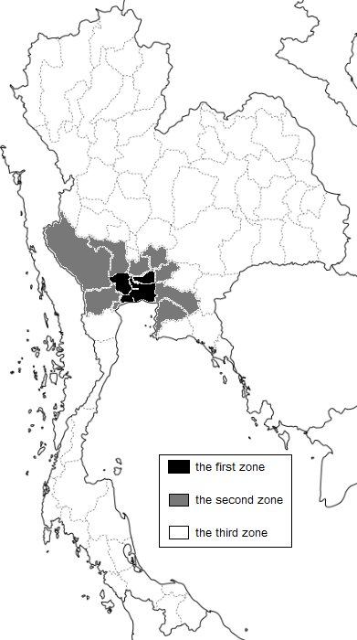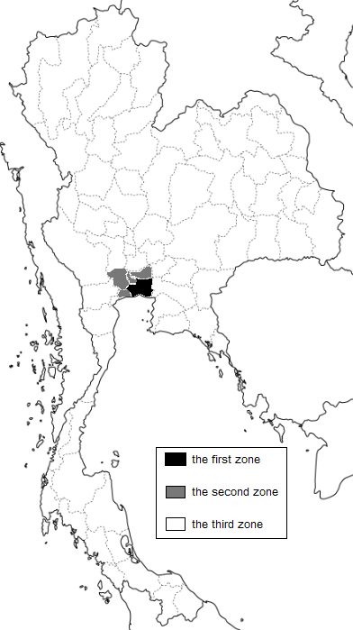
Source: Seta (2002)

Table2.2.2 Tax-system benefits of each zone (revision at Aug. 1 in 2000)
Zone | Reduction and exemption of a corporate income tax | Reduction and exemption of an import tax of machine and equipment | Exemption of import tax of a material used by an export product
The first zone | Tax exemption for three years, located at an industrial park | 50% tax reduction (limited to things over 10% import tax rates) | For a year
 | (Limited to a company located at an industrial park) |  | (Possible to prolong)
The second zone | 1)Tax exemption for five years, located at an industrial park | The same as above | For a year
 | 2) Tax exemption for three years, located at the other place |  | (Possible to prolong)
The third zone* | 1) Tax exemption for eight years regardless of location, | Tax exemption | For five years
 | 2)Located at an industrial park
 | (Ⅰ)After a tax exemption for eight years, tax reduction for five years |  | (Possible to prolong)
 | (Ⅱ)Possible to subtract twice of a transporting expenses, an electric bill and a water bill for ten years from a day to have yielded a profit
 | 3)Located at the other place, possible to subtract 25% of establishment and construction cost for ten years from a day to have yielded a profit, adding to normal depreciation expenses from a net profit
Source: http://www.asean.or.jp/index.html
* The third zone has been classified already into a underdeveloped regions and the
others at this time, but we extracted the others on this table.

Why have Japanese automobile-related companies entered Thailand more than the
other ASEAN countries after the Asian Financial Crisis?
Japanese automobile assemblers have regarded Thailand as a production and export base after the Asian Financial Crisis and the number of entry to Thailand was bigger than those of the other ASEAN countries (except 2002). For example, Asian Honda Motor Co., Ltd. has operated its main office of Asia and Oceania region in Thailand since 2004. One of the reasons that Thailand became a main export base was a depreciation of Baht. However, the currency of all countries of ASEAN4 too depreciated sharply (see Figure2.2.3). So there should be other reasons.
First, supporting industries in Thailand have relatively grown well (Lecler [2002]). In contrast, for example, supporting industries for Proton in Malaysia have not grown very well (Oshika [2007]). Second, the government of Thailand has been relatively stable. Third, the investment preferential treatment measures to Rayon, that is called Detroit of Asia, was prolonged to 2009 ⁾.

Figure2.2.3
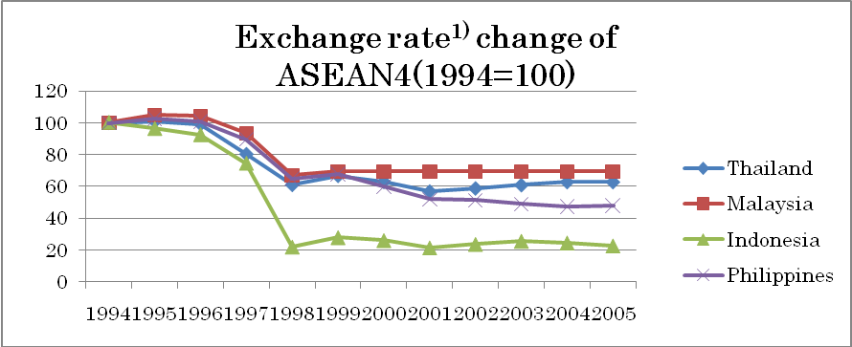
Source: International Financial Statistics
- Period average

Rayong should have been included in the second zone, but the government of Thailand worried about a failure that Thailand couldn’t recover from damage of the financial crisis and decided to prolong the investment preferential treatment to 2004. Finally, Thailand is adjacent to Indochina (Vietnam, Laos, and Cambodia). This region is expected to develop in future. Thailand can be a gateway to Indochina (Harada and Ino [1998]).
The wage rates in Thailand have risen in the past few years. However, Japanese automobile-related companies still regard Thailand as an important country for their investment destination (see Figure2.2.4).

Figure2.2.4
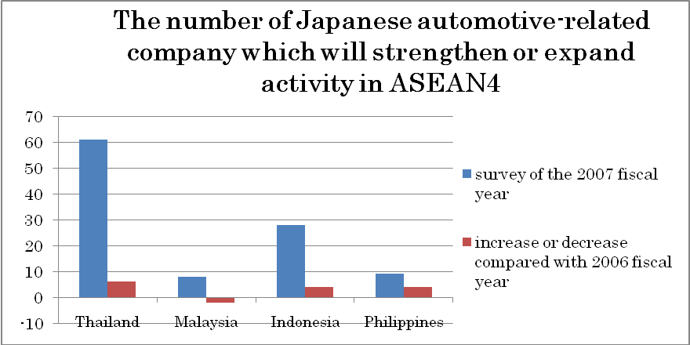
Source: JBIC (2007)

3. Role of Japanese firms for the formation of automobile cluster in Thailand

3-1. Entry of Japanese firms into Thailand and the development of Automobile Cluster in Thailand
As was discussed in Chapter 1, Japanese automobile firms have dominated the automotive production in Thailand. And the Thai local entrepreneurs started automotive business staggered by the entry of Japanese automotive firms.
Using the data of 805 automotive firms in Thailand), we investigate the spread effects of entry of Japanese firms on the establishment of the local automotive firms.
Table 3.1.1 shows the number of entry of Japanese firms and the number of establishment of local automotive firms in Thailand.

Figure3.1.1 The Number of Establishment of Automotive Firms in Thailand
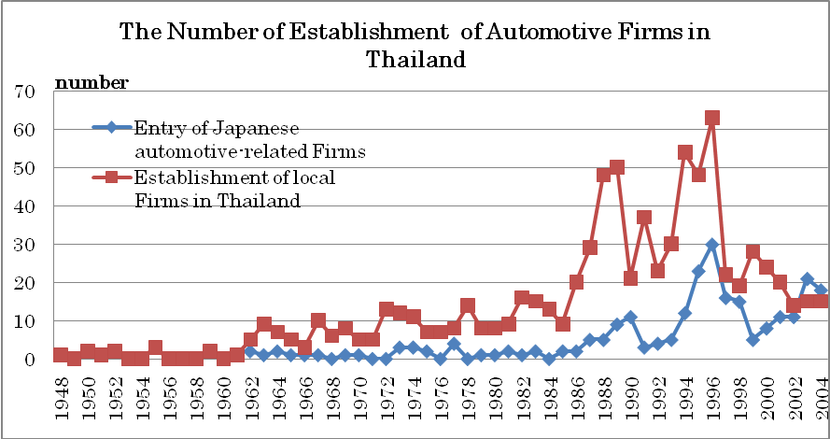
Source: ASEAN & Thailand Automotive Industry Directory 2006-2007

In 1960s, the Thai government adopted favorable measures to attract foreign capital in automobile sector, because at that time there was not enough automotive production technology in Thailand.
In 1962 Hino Motors Company, collaborating with TOYOTA, has settled their factory in Bangkok and started selling trucks and buses. Also Nissan Motors Company, which settled their factory in Samutprakorn, started to produce cars . In the same year, five Japanese automotive-related firms were established. In 1963, NIPPON HATSUJO KABUSHIKI KAISYA (NHK Spring), which produced springs, seats and other components, entered to Thailand. In 1964, TOYOTA Motors Company started production and sales of cars. In 1966, ISUZU started to produce large and small vehicles, and started to assemble pickup-trucks and components. Next year Honda Motors Company started to produce motorcycles and four-wheeled vehicles (Table 3.1.2)

Table 3.1.2 Japanese Automotive related firms which entered Thailand in 1960s
Firms | Establishment  year | Location | Business
Hino Motors Sales Thailand Ltd | 1962 | Bangkok | Sale of Hino trucks and buses
Siam Motors & Nissan Co.,Ltd | 1962 | Samutprakorn | Production of automobile
NHK Spring Thailand Co.,Ltd | 1963 | Samutprakorn | Production and sale (kenka springs , seats, elaborate springs and components)
Toyota Motor Thailand Co.,Ltd | 1964 | Samutprakorn | Production and sale  (automotive and components)
Asian Honda Motor Co.,Ltd | 1964 | Bangkok | Presiding function of the business in ASEAN  Export of motorcycles and cars  Sale and export of mainframe manufacture
Aoyama Thai Co.,Ltd | 1965 | Samutprakorn | Production and sale of motorcycles and components and bolt
Isuzu Motors Co Thailand | 1966 | Samutprakorn | Sale and export of large/small car on business, assemblage of pickup-trucks, and component for vehicles
Thai Honda Manufacturing Co.,Ltd | 1967 | Bangkok | Production of motorcycles , cars,  versatile manufacture and components
Thai Buridgestorn Co.,Ltd | 1969 | Bangkok | Production and sale of the tire for automobile

Automotive related firms in Thailand have established one after another in the 1960s. Although few firms established before 1961, after 1962 the number of automotive related firms (automobile components/parts firms) in Thailand increased.
From 1985 to 1991, a lot of automotive related firms were established (Figure 3.1.1). From 1980 to 1991, GNP per capita of Thailand was doubled and the advantage annual growth rate during this period was 7.6%. During this high growth period, a lot of automobile related firms were settled, and its growth rate was 16.2% per annum [OGAWA (1995)].
On the other hand, Japanese firms promoted FDI to develop the new businesses after the Plaza Accord, “An ultra-strong yen rate (1$=\95)” promoted FDI (Table 3.1.3). In this period, the companies entered to Thailand were mainly the automotive components firms. The entry of Japanese automotive components firms has promoted the establishment of automotive related local firms.

Table 3.1.3 The location & entry period of Japanese components/parts makers
 | Bangkok | Samutprakorn | Chonburi | Rayong | Chachoengsao | Phathumthani | Ayutthaya | Other | Sum
1962～69 | 4 | 5 | 0 | 0 | 0 | 0 | 0 | 0 | 9
1970～84 | 6 | 5 | 3 | 1 | 2 | 2 | 0 | 1 | 20
1985～89 | 8 | 7 | 1 | 1 | 0 | 5 | 0 | 1 | 23
1990～96 | 12 | 10 | 23 | 13 | 8 | 2 | 13 | 7 | 88
1997～07 | 28 | 13 | 30 | 25 | 4 | 3 | 16 | 11 | 130
合計 | 58 | 40 | 57 | 40 | 14 | 12 | 29 | 20 | 270
Source: Toyoeconomics[2008] A compendium of the advance of Japanese company into foreign markets
Note: Except a two-wheeled vehicle components

According to Figure3.1.4, more and more local firms were establishing in Bangkok in 1960s according to the increasing number of Japanese automotive firms. However, in the late 1970s, when the entry numbers of Japanese firms stagnated in Bangkok, nevertheless a lot of local firms were established. Because Bangkok is the capital city of Thailand and the economic activities were brisk, we can think that without new entry of Japanese firms there appeared the structure of agglomeration.

Figure3.1.4 The Number of Automotive Firms at Bangkok
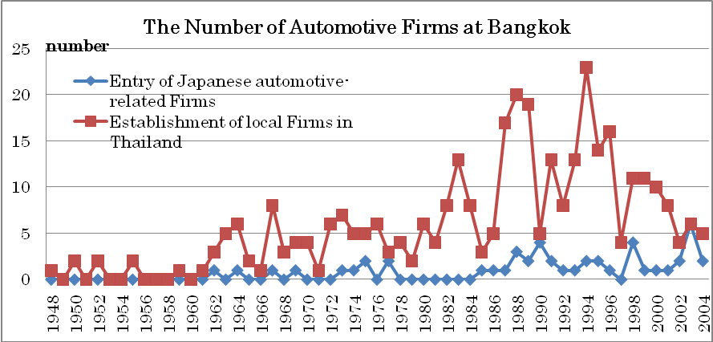
Source: ASEAN & Thailand Automotive Industry Directory 2006-2007

In 1960s we can see the same trends in Samutprakorn where many Japanese automotive related firms were entered (Figure 3.1.5). A lot of local firms were established in the year or the next year when Japanese firms entered. Number of establishment of local firms in Samutprakorn is more outstanding than that in Bangkok.

Figure3.1.5 The Number of Automotive Firms at Samutprakorn
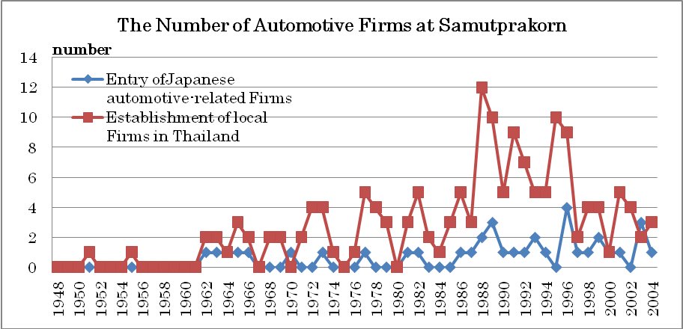
Source: ASEAN & Thailand Automotive Industry Directory 2006-2007

Next we focus on the number of automotive firms in Eastern Seaboard (ESB), i.e., Chonburi, Rayong, Chachoengsao, where automobile cluster had been developed from the beginning of 1980s. As Firure3.1.6 shows, the local automotive related firms have been established in the year when Japanese automotive related firms entered (Figure 3.1.6). Japanese automotive related firms started to enter to the Eastern Seaboard in 1990s. The Thai government designated ESB as the heavy and chemical industries area and provided incentives to encourage investment by foreign-affiliated companies. The aim of this policy is to develop industrial cluster by establishing local firms in the neighboring area of ESB.

Figure 3.1.6 The Number of Automotive Firms at Eastern Seaboard (ESB)
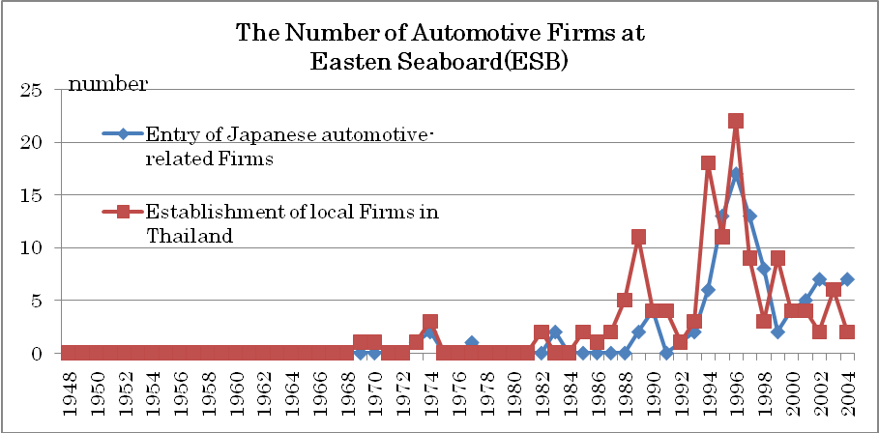

In addition, a lot of local automotive related firms have business relations with Japanese major assemblers (Table 3.1.7).

Table 3.1.7 Major Domestic Customer’s List

Although these dates are not complete), we can see many local automotive firms which have business relations with Japanese automotive related firms.
In short there is a close relationship between the time when Japanese automotive related firms entered into Thailand and the time when local firms were established. Considering the Thai local automotive related firms have supplied automobile components to Japanese firms, we can say that the entry of Japanese firms into Thailand contributed the development of automobile clusters in Thailand.

3-2. Japanese automobile firms as an intermediary of technology transfer
The section focuses on technological transfer from the Japanese engineers to the Thai workers in the Thai automobile industry. The automobile industry cluster played an important role to nourish skilled workers.
Technological transfer from Japanese firms to Thai firms started in the late 1970s.
Joint ventures with Thai auto-parts suppliers were originally the main route of technological transfer. At that time the Thai automobile industry was under the progressive localization scheme so it was much less costly for Japanese auto makers to use local suppliers than to import auto-parts from other countries. However, Thai auto-parts makers had not enough technologies and skills. It became necessary for the Japanese global auto makers to have long-term partners who can produce more sophisticated parts and components. At the same time, Thai local suppliers needed to upgrade their technology for production processes. As the Japanese automobile firms formed joint ventures with the Thai local companies, the production technology transferred to the local suppliers.
The automobile market had been growing rapidly in Thailand. However, serious problem was the shortage of skilled workers. The Japanese automobile makers were forced to train the workers by themselves. To prevent the workers from quitting the firm after the training, the Japanese companies have invested in the specific skill training by adopting the Japanese employment system. The Japanese auto makers have invested heavily in human resource development (HRD). HRD program was ranging from the provision of OJT (on the job training) and in-house Off-JT (off the job training), backing up workers to train at the training centers in Japan.
There were many practical attempts to improve skills of local suppliers and assemblers in Thailand. As an example, assembler in Thailand made a skill improvement system with Japanese parent company. The assembler introduced the Working Life Plan (WLP), which was consisted of an evaluation of technical workers, job rotation, education and training and advancement. WLP tried to make the goal achievement for skill formation and career path of each worker while Japanese company tried to promote making such a system in the company. As the first stage for WLP, the assembler made a system of education and training based on Japanese company system. The level of workers’ ability is divided into four phases. All workers were expected to reach to C level in 6 years from entering the company, B level in 10 years and A level in 15 years. Each level consisted of suitable job rotation, education and training and advancement. Education and training was categorized into three phases at each level; BK (Basic Knowledge), TK (Technical Knowledge) and PS (Practical Skill). At each level the improvement was evaluated by practical exam and paper test. The system was recognized as self-development of human resources. The system had an important role for technology transfer from Japanese company.
Another example is the training of Thai engineers by Japanese supplier. The Japanese supplier made manuals called “Work Bible” to conduct education and training efficiently. It covered the operation of machinery maintenance, quality check, and treatment of defective products. Through making manuals of specific procedures, the Japanese supplier aimed to expand Thai worker’s ability. Using manuals, Japanese engineers could more easily transfer technology to Thai workers. As a result, these manuals were effective to improve QCD (Quality Cost Delivery) and to promote technological transfer.
The number of skilled workers has been gradually increased thanks to the effort by the Japanese automobile makers. A successful case of technological transfer is the formation of the Toyota Cooperation Club (TCC). TCC is an association of suppliers to Toyota Motor Thailand (TMT). There were 117 member suppliers including 35 local suppliers at TCC in 2004. To join TCC, the automobile suppliers had to transact with TMT at least five million annually and they should pay annual membership fee of 20 thousand baht to TCC. There are six major types of activities at TCC: (1) annual conferences (2) TCC Executive Committee meeting (3) Quality Assurance Kaizen (study improvements) activities (4) Cost Kaizen activities (5) quality control circle activities (6) TCC lecture.
In these activities, TMT needed an active transfer of Toyota Production System (TPS) to improve productivity. Therefore, TCC encouraged local suppliers to make their own efforts to improve their competitiveness. An example was a voluntary learning process (jishiuken) (see table 3.2.1). Leading suppliers that have Japanese engineers who accustomed to TPS made each group. In each group, other members learnt more advanced technology. Forty companies participated in the voluntary learning process in 2003. The main purpose of the activity in 2003 was to bring up more leading companies and to expand Cost Kaizen activities by promoting these voluntary improvement activities to new participant companies. Another example related to TPS was TPS School (douzyou). Five local suppliers were selected and Toyota Motor Thailand sent experts to these local suppliers. The program tried to strengthen human resources development by letting the Thai local suppliers acquire fundamental education and practical experience. Through these activities, Thai workers have become more skillful.

Table 3.2.1 Voluntary Learning Process (2003)
Group | group A | group B | group C | group D
main supplier | NHK Spring (T) Co., Ltd. | Thai Koito Co., Ltd. | Summit Auto Seats Industry | Enso International
 | Yarnapund Co., Ltd. | Thai Asakawa Works | Toyoda Gosei | Toyoda Gosei Rubber
 | YS Pund Co., Ltd. | Toyoda Machine Works | Kallawis Auto Parts Industry | Siam Kayaba
 | Fujitsu Ten (T) Co., Ltd. | Chuo Thai. Cable | Aapico Hitech | Feltol Manufacturing
 | Hino Motors Mfg (T) Co. Ltd. | Inoac Industries | Siam AT Industry | Inoue Rubber
 | Murakami Ampas (T) Co. Ltd. | Siam Aisin | ATB Textiles Industry | CH. Auto Parts
 | STM | SK Auto Interior | Toacs | Sathien Plastic & Rubber
 | Toka Rika (T) Co., Ltd. | Somboon Somic Manufacturing | Thai Seat Belt | Thai Engineering Products
 | Sanko Gosei Technology | Tokai Eastern Rubber | Thai Steel Cable | Maruyasu Industries
Source: Management Transfer to Thai local auto-parts suppliers P27

Summing up. Japanese automobile firms have had a variety of activities to promote technological transfer: introducing Working Life Plan, making Work Bible and making Toyota Cooperation Club and so on. Although there was not enough numbers of engineers to upgrade international competitiveness in Thailand at that time, these activities contributed to increas skilled workers in Thailand.

3-3. R&D as a new role of Japanese firms in Thailand’s automotive industry
This section focuses on establishment of research and development (R&D) base in Thailand as a new role of Japanese firms for the formation of automobile cluster in Thailand. By promoting localization of production and supply chain, it became possible for Japanese automobile firms to produce and sell their products globally. As a next step, localization of R&D has been desired by Japanese automobile firms (Kobayashi(2007)).
Table 3.3.1 shows the number of R&D base of Japanese automotive firms by region. As shown in this table, establishment of Japanese company’s R&D base in the U.S. and Europe had started in 1980’s. And recently, they started to establish R&D base in Korea, China and Thailand.
The details of the establishment of R&D base in Thailand by Japanese major assemblers are shown in Table 3.3.2. They started to establish R&D bases in 1990’s onwards up to today. Furthermore, they have attempted to enhance the development capacity. Toyota established Toyota Motor Asia Pacific Engineering and Manufacturing Co., Ltd., which aimed at development and evaluation of locally produced vehicles in the Asian region. For nest IMV⁾, Toyota plans to increase of R&D staffs from 500 in 2008 to 1000 in 2015 development（Nikkei Business 2008/3/10）. Honda also started to establish R&D base, Honda R&D Asia Pacific Co., Ltd. and Honda Lock R&D Asia Co., Ltd., in Thailand. In 2007, Honda spent 2.4 billion baht to built a new building for automobile research institute in Bangkok so that it improved development capability for eco-car（Nikkei newspaper 2007/6/6）. Isuzu established R&D base in Thailand in 1991. Isuzu are going to start localization of R&D for pick-up trucks. The aim is to produce their products timely and to cope with diversified market needs. The company will also transplant test and evaluation departments from Japan and increase R&D staffs to strengthen R&D base in Thailand (Isuzu’s press release 2006/8/9）.

Table 3.3.1 Number of Japanese automotive R&D base by region
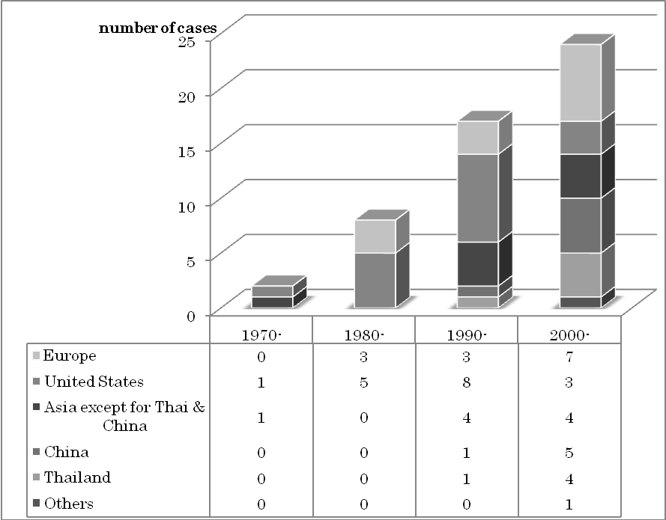
Source: Each company’s HP& Toyo Keizai[2008],”Kaigai Shinsyutu Kigyous Soran Kaisha Betuhen 2008(List of Japanese Affiliated Firms categorized by Company 2008)”

Table 3.3.2 Business deployment by major Japanese assemblers
Toyota | Start of productions | Major activities & products
Toyota Motor Thailand Co., Ltd. （TMT） | 1964.12＊ | Car assembling
Toyota Auto Body Thailand Co., Ltd. （TABT） | 1979.5＊ | Stamped parts
Thai Auto Works Co., Ltd. （TAW） | 1988.5＊ | Car assembling
Siam Toyota Manufacturing Co., Ltd.（STM） | 1989.7＊ | Engine, engine parts
Toyota Motor Asia Pacific Engineering and Manufacturing Co.,Ltd. | 2005.4＊ | Development and evaluation efforts for locally produced vehicles as well as operational support for Toyota production affiliates in Asia, Oceania and the Middle East

Honda | Start of productions | Major activities & products
Asian Honda Motor Co., Ltd. | 1964.1 | Honda’s Asia-Oceania regional headquarters
Asian Autoparts Co., Ltd. | 1989.4＊ | Manufacture of parts for Honda products
Honda Engineering Asian Co., Ltd. | 1991.1 | Development of manufacturing tools and equipment for ASEAN region production facilities
Thai Nippon Seiki Co., Ltd. | 1995.11＊ | Manufacture of parts for four-wheeled vehicles and motor cycles
Honda Lock Thai Co., Ltd. | 1996.12＊ | Manufacture of parts for four-wheeled vehicles and motor cycles
Thai Toyo Denso Co., Ltd. | 1998.6＊ | Manufacture of parts for four-wheeled vehicles
Honda Automobile (Thailand) Co., Ltd. | 2000.12 | Manufacture and distribution of automobiles  Manufacture of engine components
Honda R&D Asia Pacific Co., Ltd. | 2005.12 | Research, development and surveys of four-wheeled vehicles in Asia
Honda Lock R&D Asia Co., Ltd | 2006.3 | Research & development of parts for automobiles
Asian Parts Manufacturing Co., Ltd. | 2006.4 | Manufacturing stamped body panel service parts for automobiles

Isuzu | Start of productions | Major activities & products
Isuzu Motors Co., (Thailand) Ltd. | 1966.4 | Manufacture of Commercial Vehicles and Pickup Trucks
Tri Petch Isuzu Sales Co., Ltd. | 1974.11 | Import and Distribution of Commercial Vehicles and Pickup Trucks
Isuzu Engine Manufacturing Co., (Thailand) Ltd. | 1987.7 | Manufacture and Distribution of Diesel Engines
Thai International Die Making Co., Ltd. | 1987.9 | Manufacture of Dies and Stamping Parts
Isuzu Technical Center of Asia Co., Ltd. | 1991.12 | Development & information center
IT Forging (Thailand) Co., Ltd. | 1994.12 | Manufacture and Distribution of Forgings
Isuzu Operations (Thailand) Co., Ltd. | 2002.3 | Export of Pickup Trucks
Source：Each company’s HP& Toyo Keizai[2008],”Kaigai Shinsyutu Kigyous Soran Kaisha Betuhen 2008(List of Japanese Affiliated Firms categorized by Company 2008)”
Note：* start of operations

Kanai(2003) pointed out that enterprises and various organizations which composed the cluster needed to compete and cooperate dynamically based on innovation for the improvement of industrial cluster. And these kinds of R&D bases generate product innovation. Innovative activities improve industrial cluster and industrial cluster promote innovative activities. Of course, R&D center is not the sole source of development of industrial cluster. To generate new ideas, the cooperating system and networks among companies, research institutions, and universities are necessary.
So the establishment of R&D base in Thailand by Japanese automobile firms is not the sufficient condition but it is one of the important factors for further development of Thailand automotive cluster.

References

Chaw, Y. (2004) “Japanese Company and Promoting Measures and issue of Malaysian Automotive Industry” Regional Policy Study, The Regional Policy Institute of Takasaki Economy College, Vol.6, No.4, pp.113-118
Dunning, J. H. (1977) “Trade, Location of Economic Activity and the MNE: A Search for an Eclectic Approach”, in B. Ohlin et al. (eds.) The International Allocation of Economic Activity, London: Macmillan, 1977.
Dunning, J. H. (1979) “Explaining Changing Patterns of International Production: In Defense of the Eclectic Theory”, Oxford Bulletin of Economics & Statistics, November, pp.269-295, 1979
Enatsu, K., Hasegawa, S. and Hasegawa, R. (2008) “International Business Theory”, ChuoKeizai-sha
FOURIN(2007)” Sekai-Zidousha-Toukei-Nenkan 2007 (The Global Automotive Statistics 2007)”
Harada, Y., & Ino, Y. (1998) “Introduction to Thai Economy” Nippon-Hyoron-Sha
Iwauchi, H. (1994) “Industrial Policy of Malaysia and Japanese Company” Toyama University Bulletin, Tomidai Economy papers, Vol.40, No.2, pp. 361-374
JBIC (2000) “The Kingdom of Thailand, Developing the Eastern Seaboard Synthesis Impact Assessment” Report of Institute of Development Finance, April, 2000, No.2, pp41-69
JBIC (2007) “Report of Survey related with an Overseas Undertaking expansion of Manufacturing Company of Japan, Quick Report” Institute of Development Finance
Kanai, K.(2003),”Kurasuta riron no kento to saikoutiku (Consideration and Reconstruction of Cluster Theory) ” in Ishii, Y., Fujita, M., Maeda, N., Kanai, K. and Yamasaki, A.(eds.) Nihon no sangyou kurasuta senryaku (Strategy for Cluster Initiatives in Japan), Yuhikaku
Kawabe, Y.(2004)” Management Transfer to Thai local auto-parts suppliers; with a central example of TCC member companies”, ASEAN-Auto Project No.04-6,Working Paper Series Vol. 2004-21
Kikai-Shinko-Kyokai-Keizai-Kenkyuzyo (2001)”Report of Machine Industry Economy H12-8 ”
Kobayashi, T. (2007),”A Study of “Localization of Development” in Japanese Automotive Industry”, Kikai-keizai-kenkyu, No.38, pp.71-76
Kubo, H. (2001) “Contemporary Phase of Thai Indigenous Economy and Society” Chuo University Publishing Department
Lecler, Y. (2002) “The cluster role in the development of the Thai car industry” International Journal of Urban and Regional Research, Vol.26.4, December, 2002 pp.799-814
Legewie, J. (2000) “Driving Regional Integration: Japanese Firms and the Development of the ASEAN Automobile Industry.” In Facing Asia – Japan’s Role in the Political and Economic Dynamism of Regional Cooperation, edited by V. Blechinger and J. Legewie, Iudicium.
Media Overseas (2004) “ASEAN & Thailand Automobile Industry Directory 2004”
, (2006) “ASEAN & Thailand Automobile Industry Directory2006-2007”
Mizuho Research Institute(2003)”Thailand automotive industry”, Mizuho Financial Group
Mori, M (2000)”The formation and development of automotive industrial cluster in Thailand” Sakura Institute of Research Center for Pacific Business Studies, RIM ,Vol. 4, No. 51.
Oshika, T. (2007) “Progress of Integration of ASEAN Market and Impact for Automotive Industry” JAMAGAZINE, March, 2007
Porter. M. (1998),“Clusters and the New Economics of Competition”, Harvard Business Review, Nov.-Dec.
Rosenfeld. S (1997) “Bringing Business Clusters into the Mainstream of Economic Development”, European Planning Studies 5(1): 3-23.
Seta, H. (2002) “The Policy Correcting a Regional Gap and Its Process Accompanying the Globalization” available on: http://www.regionalplanning.net/seta/ddd/abstract.htm
Togo, K. (2001) “Transfiguration of Development Policy after the Crisis” Institute of International Currency, Report of Association of Financial Issue at South-East Asia Region, February, 2001
Toyo Keizai(2008) ”Kaigai Shinsyutu Kigyous Soran Kaisha Betuhen 2008(List of Japanese Affiliated Firms categorized by Company 2008)”
Ueda. Y. (2007) “Japanese FDI and Auto Parts Industries in Thailand”, Doshisya University Economic Review, Vol.58 No.4, pp.87-117
UNCTAD(2001) ”World Investment Report 2001”
Yamashita, S.(2004)” Development and export orientation of Auto-parts Industry in Thailand”

Website
ASEAN Japan Center: http://www.asean.or.jp/index.html
Japan External Trade Organization (JETRO): http://www.jetro.go.jp/indexj.html
Free map: http://www.freemap.jp/about_this_site.html

Cluster originally meant bunch of grapes and is used to indicate a group or a gathering.
1) Variables concerning with the choice of location of MNEs range widely. The OLI paradigm classifies them into three factors: the ownership-specific advantages, the location-specific advantages , and the internalization-incentive advantage (Enatsu et al. [2008]).
2) The encouraging investment policy is formed by the following things.1. reduction and exemption of a corporate income tax, 2. reduction and exemption of a import tax of machine and equipment, 3. exemption of import tax of a material used by an export product, 4.permission of an entry into the country and a foreigner working by an engineer, an expert and a family, 5. permission of an entry into the country and a working by a foreigner for a feasibility study, 6. permission of a landholding to do an encouraged undertaking, 7. assurance of a remittance of foreign currency abroad, 8. Reduction of an income tax of a material used by a domestic sales product
3) Foreign companies must have applied for the encouragement till the end of 2004.
) There are 2132 automotive related firms in Thailand (ASEAN & Thailand Automotive Industry Directory 2006-2007). This paper uses the 805 firms date which written establishment year.
) The firms which written trading partner are only 72 in 2132 [ASEAN & Thailand Automotive Industry Directory 2006-2007]. It is considered that a lot of local automotive firms have relations on business with Japanese firms. Although some of the rest of 1660 firms deal with Japanese firms, it is predict that one local firm deal with other local firms to supply automotive components for Japanese firms.
⁾ IMV (Innovative International Multi-purpose Vehicle) are strategic cars for emerging markets. Toyota started “IMV project”, which build optimal system of production and supply from 2004. IMV are exported to the world from Thailand, Indonesia, South Africa and Argentine.
⁾ Innovation can be divided into “process innovation” and “”product innovation”. “process innovation” means innovation that improve the quality and cut the cost of the existing products. “Product innovation” means innovation that produce original value-added products.

